**Lesson 5 Demo 1**

**Installing Maven Integration Plugin**

**Objective:** Install Jenkins Maven integration plugin for integrating Maven build automation.

**Tools required:** Jenkins

**Pre-requisites:** You need to have a Jenkins up and running.

Steps to be followed:

1. Log in to Jenkins CI tool and install Maven Integration plugin.

**Step 1: Log in to Jenkins CI Tool and install Maven Integration plugin.**

1. Login to Jenkins CI tool with admin user and install Maven Integration plugin and configure it:
2. Access Plugin manager and then navigate to Available tab to install Maven Integration plugin.

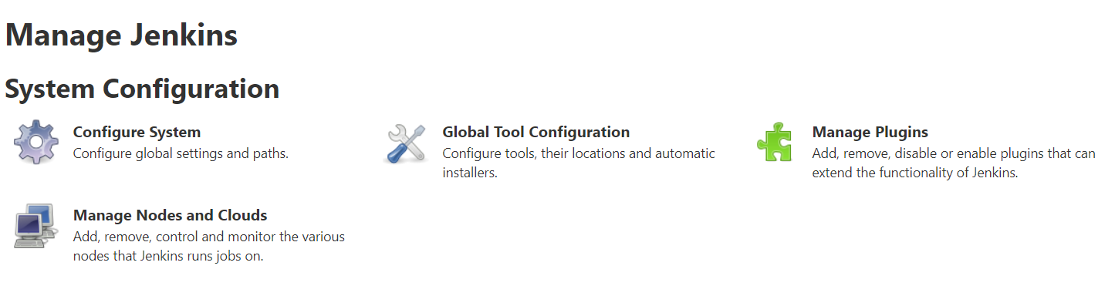

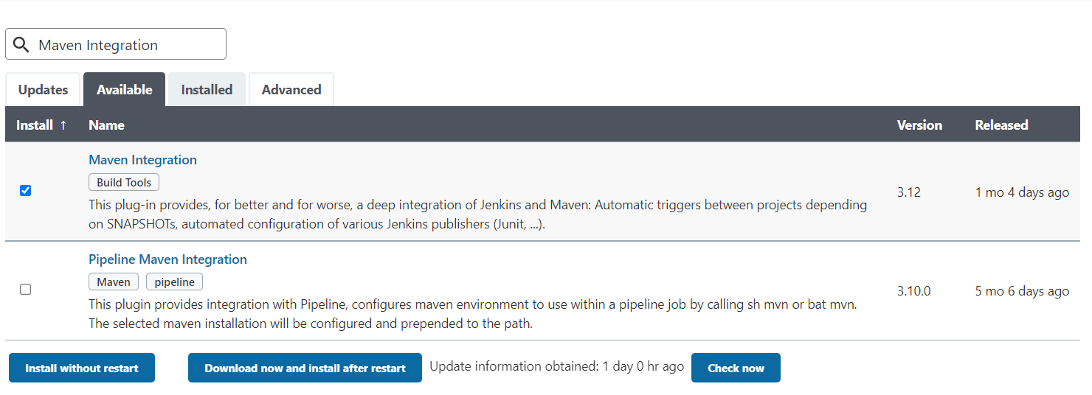

1. Once plugin is installed restart Jenkins to activate plugin in Jenkins.